Query 1.1: Display the name and IMBb rating of all the movies according to
their IMDB rating (in descending order); if multiple movies have the same
IMDB rating then rearrange those movies alphabetically according to their
names.
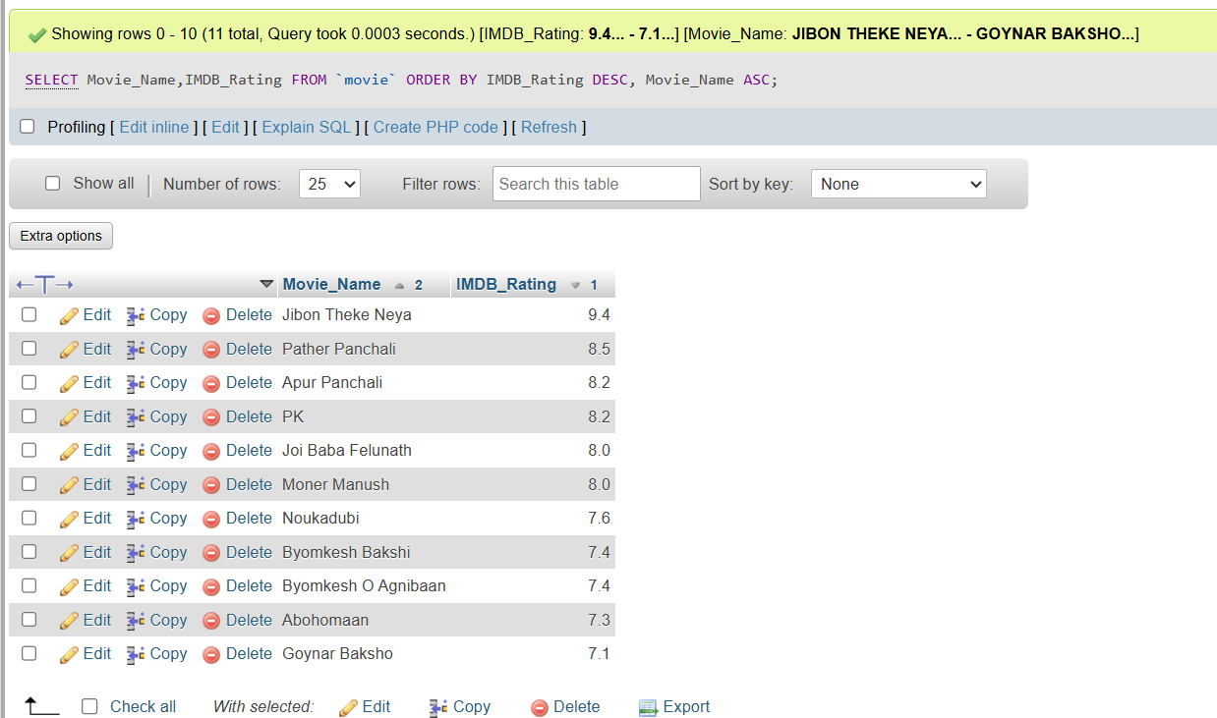
Query 1.2: Find the total number of movies in the database.
SELECT COUNT(*) AS Total_movies FROM `movie`;
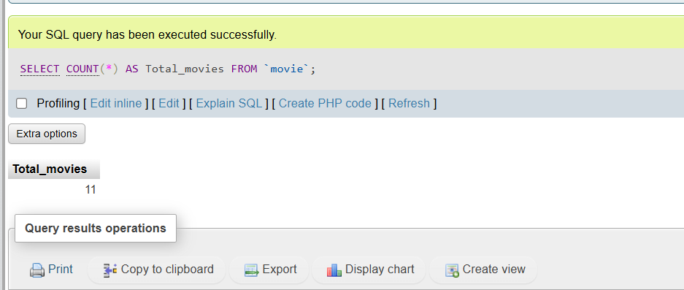

Query 1.3: Find how many movie-genres are there in the database.
SELECT COUNT(DISTINCT Genre) AS Movie_Genre FROM movie;

Query 1.4: Find the total number of movies in each genre.
SELECT Genre, COUNT(*) FROM movie GROUP BY Genre;
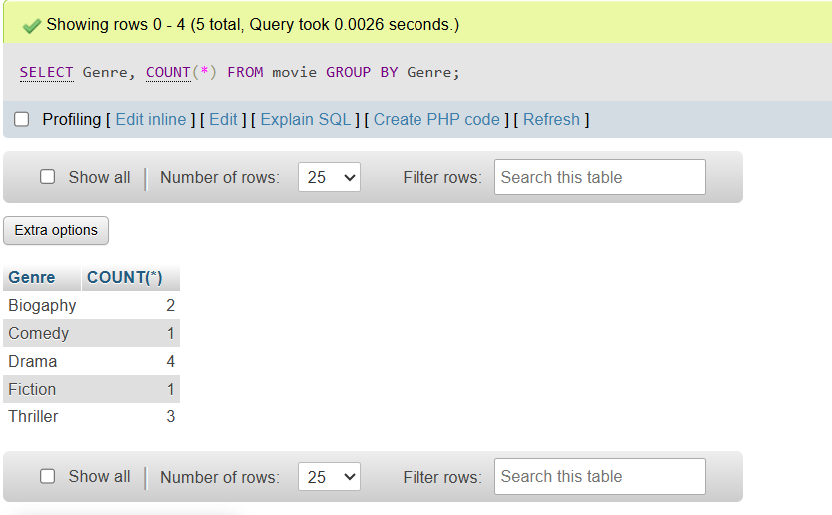
Query 1.5: Find the average IMDB rating of all the movies of the drama
genre.
SELECT Genre, ROUND(AVG(IMDB_Rating),1) FROM movie WHERE Genre = 'Drama' GROUP BY Genre;


Query 2.1: Find the number of movies directed by a director on average.
SELECT ROUND(AVG(No_Of_Films),0) FROM director;

❖ Query 2.2: Find the name, genre, IMDb rating and the name of the director
of all the movies directed by Satyajit Ray, Zahir Raihan, Rituparno Ghosh
and Kaushik Ganguly.
SELECT Movie_Name,Genre,IMDB_Rating, Director_Name FROM `movie` JOIN director ON movie.Director_ID = director.Person_ID WHERE Director_Name IN ('Saytajit Ray', 'Zahir Raihan', 'Rituparno Ghosh', 'Kaushik Ganguly');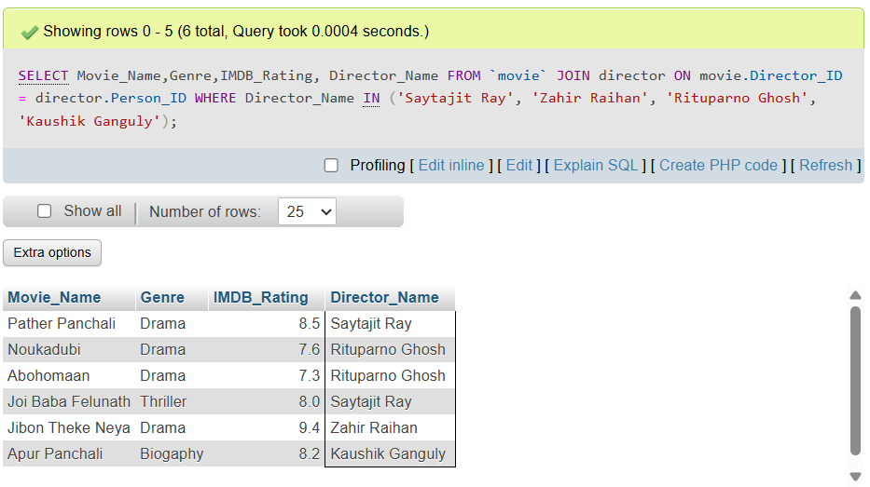

Query 2.3: Find the name and current age of all the directors and actors.
SELECT Director_Name AS Name, Year(Now())-D.Birth_Year AS Age FROM director as D UNION SELECT A.Actor_Name, Year(Now())-A.Birth_Year FROM actor AS A;
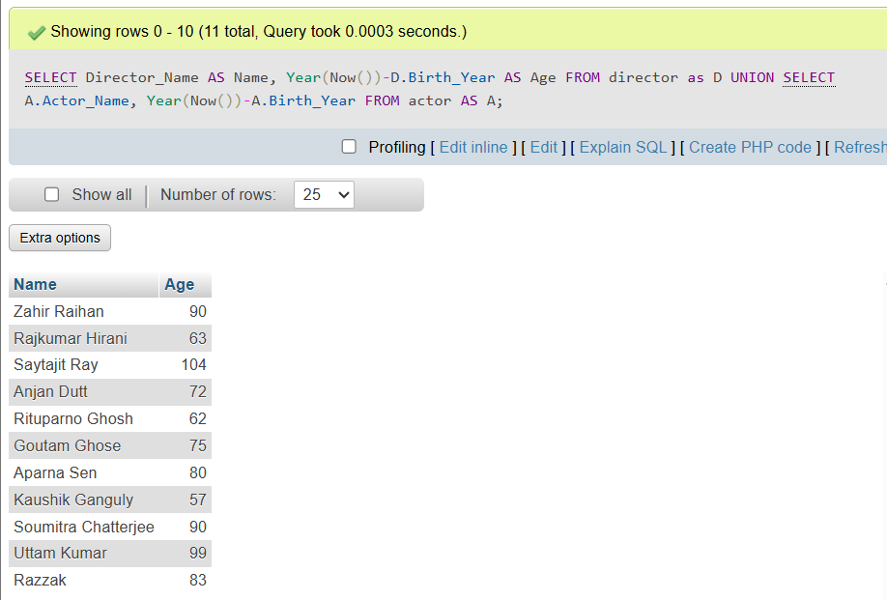

Query 2.4: Find the name, current age, number of films as an actor and
number of films as a director of those actors who directed at least one film.
SELECT D.Director_Name, Year(Now())-D.Birth_Year AS Age, D.No_Of_Films, A.No_Of_Films FROM director AS D join actor AS A on A.Person_ID = D.Person_ID;
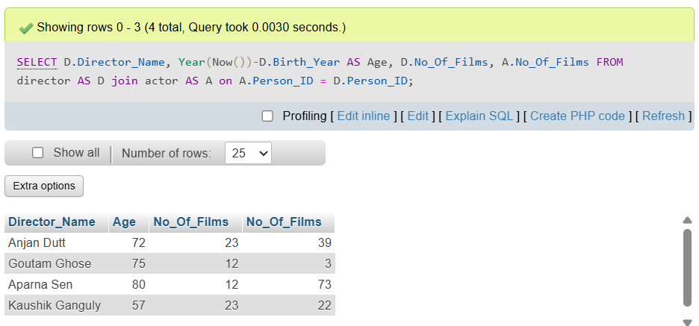
Query 2.5: Consider that there is no No_of_Films attribute in the Director
relation. Now find the name of all the directors and number of movies
directed by each director.
